**SOOTHING SOUND ACTIVITY**

Instructions:

1. Turn on a sound that you think will be soothing.
2. Adjust the volume until you find the level that is most soothing to you (from low to comfortable level, but not loud).
3. While you listen to the sound, determine how soothing the sound is to you, even with tinnitus:

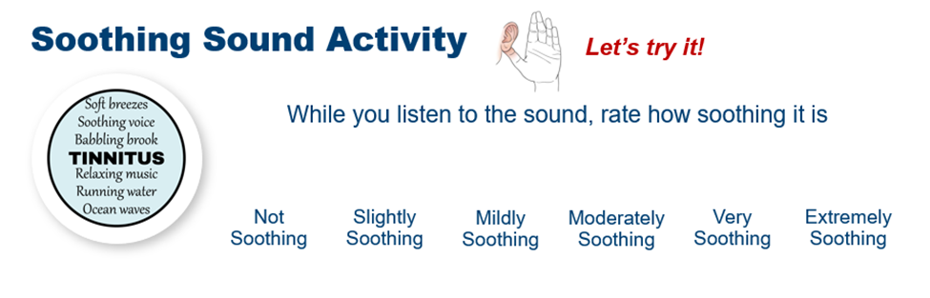

1. Try a variety of sounds that you think will be soothing to you.

|  |  |
| --- | --- |
| What sound did you try? | How soothing was it to you? |
|  |  |
|  |  |
|  |  |
|  |  |
|  |  |

Your Notes: