**INTERESTING SOUND ACTIVITY**

Instructions:

1. Listen to a sound that is interesting or meaningful to you.
2. Adjust the volume at a comfortable level for you (not loud!).
3. Choose the percentage of attention focused on that interesting sound.

 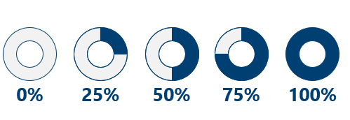

**Attention Focused on Interesting Sound**

|  |  |
| --- | --- |
| What sound did you try? | What was the percentage of attention that you focused on the sound that you tried? |
|  |  |
|  |  |
|  |  |
|  |  |
|  |  |

1. Make sure to try different sounds that are interesting and meaningful to you.

Your Notes: